Sound Source Scenarios

There are four scenarios of where sound is sourced, based on angle quadrant.

Base calculation is as follows.

$$\frac{v∙i_{x}}{f_{s}}=d∙\cos{θ_{x}}$$

With $f_{s}=1000f_{s,kHz}$ and $d=d_{cm}/100$, the above equation will be

$$i_{x}=\frac{d_{cm}∙f_{s,kHz}∙\cos{θ_{x}}}{v}×\frac{1000}{100} \\ i_{x}=\frac{d_{cm}∙f_{s,kHz}∙\cos{θ_{x}}}{v}×10$$

# First Quadrant

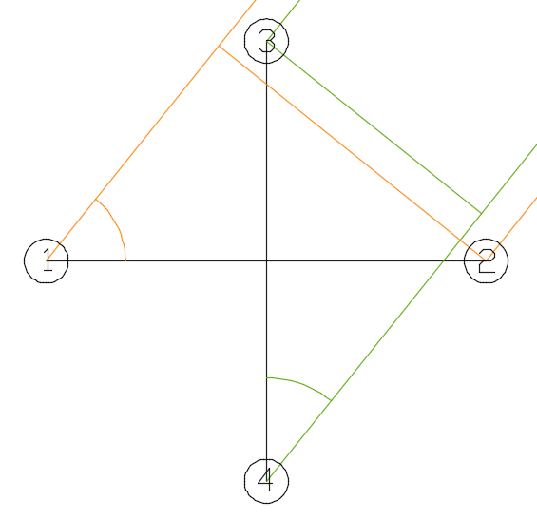

For this scenario, the location angle of the source is between 0° and 89°. Valid results are obtained by $x_{1}\left(θ_{1}\right)$ and $y_{2}\left(θ_{4}\right)$, so encoder output of $x_{2}$ and $y_{1}$ will be 255.

We know that $θ_{1}=θ$ and $θ_{4}=90°-θ$, so the equation for first quadrant will be

$$i_{1}=\frac{d_{cm}∙f_{s,kHz}∙\cos{θ}}{v}×10 \\ i_{2}=255 \\ i_{3}=255 \\ i_{4}=\frac{d_{cm}∙f_{s,kHz}∙\sin{θ}}{v}×10$$

# Second Quadrant

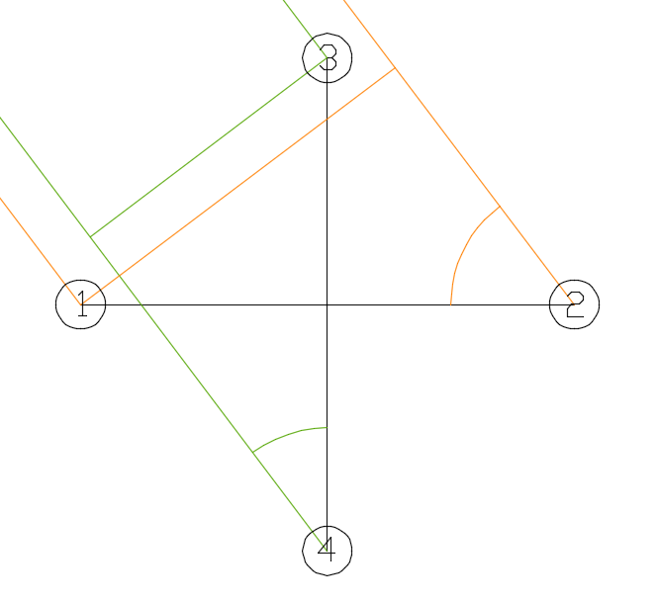

For this scenario, the location angle of the source is between 90° and 179°. Valid results are obtained by $x_{2}\left(θ_{2}\right)$ and $y_{2}\left(θ_{4}\right)$, so encoder output of $x_{1}$ and $y_{1}$ will be 255.

We know that $θ_{2}=180°-θ$ and $θ_{4}=θ-90°$, so the equation for second quadrant will be

$$i_{1}=255 \\ i_{2}=-\frac{d_{cm}∙f_{s,kHz}∙\cos{θ}}{v}×10 \\ i_{3}=255 \\ i_{4}=\frac{d_{cm}∙f_{s,kHz}∙\sin{θ}}{v}×10$$

# Third Quadrant

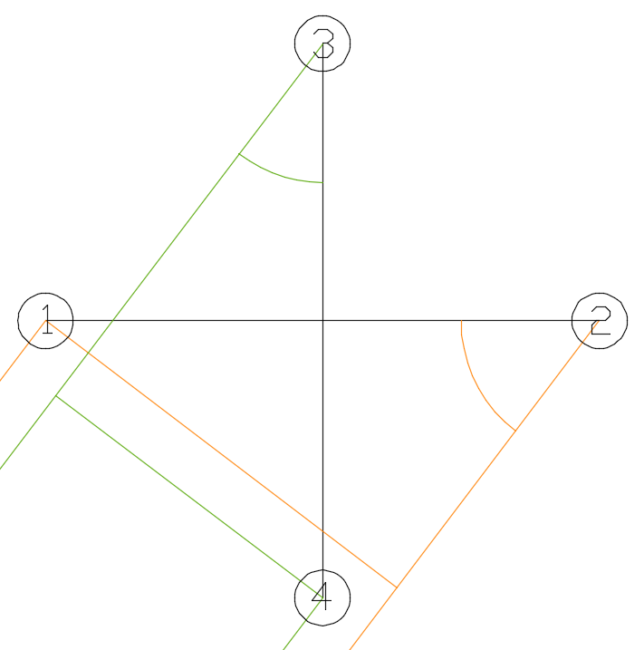

For this scenario, the location angle of the source is between 180° and 269°. Valid results are obtained by $x_{2}\left(θ_{2}\right)$ and $y_{1}\left(θ_{3}\right)$, so encoder output of $x_{1}$ and $y_{2}$ will be 255.

We know that $θ_{2}=θ-180°$ and $θ_{3}=270°-θ$, so the equation for third quadrant will be

$$i_{1}=255 \\ i_{2}=-\frac{d_{cm}∙f_{s,kHz}∙\cos{θ}}{v}×10 \\ i_{3}=-\frac{d_{cm}∙f_{s,kHz}∙\sin{θ}}{v}×10 \\ i_{4}=255$$

# Fourth Quadrant

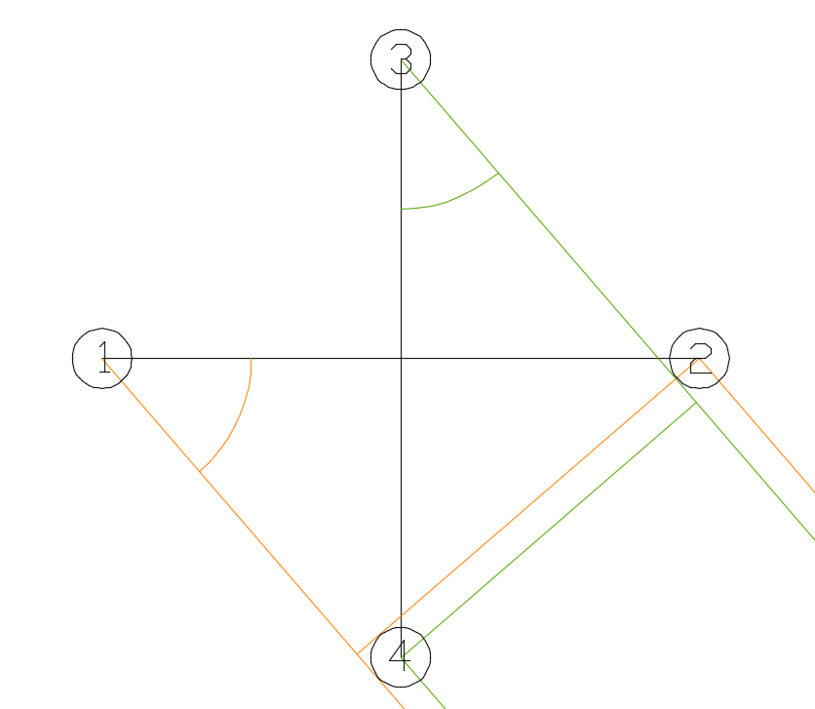

For this scenario, the location angle of the source is between 270° and 359°. Valid results are obtained by $x_{1}\left(θ_{1}\right)$ and $y_{1}\left(θ_{3}\right)$, so encoder output of $x_{2}$ and $y_{2}$ will be 255.

We know that $θ_{1}=360°-θ$ and $θ_{3}=θ-270°$, so the equation for fourth quadrant will be

$$i_{1}=\frac{d_{cm}∙f_{s,kHz}∙\cos{θ}}{v}×10 \\ i_{2}=255 \\ i_{3}=-\frac{d_{cm}∙f_{s,kHz}∙\sin{θ}}{v}×10 \\ i_{4}=255$$